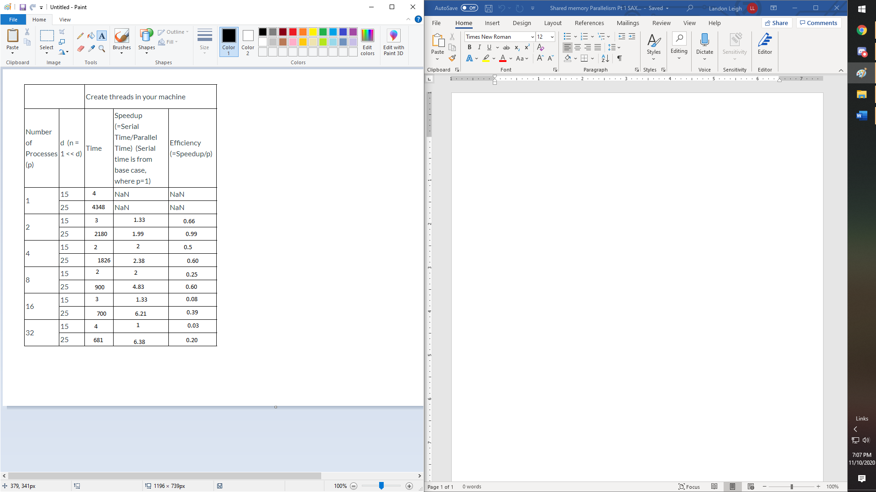

With the shared-memory parallelism, the speedup tends to go up with 4-8 processes when the d value is 15 but then tends to take more time with more processes. In all of the testing the values tend to speed it up when using a d value of 25 however if higher numbers of processes were used it seems to tend to do the same as the lower d value. The efficiency however is best when only 2 processes are used because the speedup is not worth the number of processes used.